1. 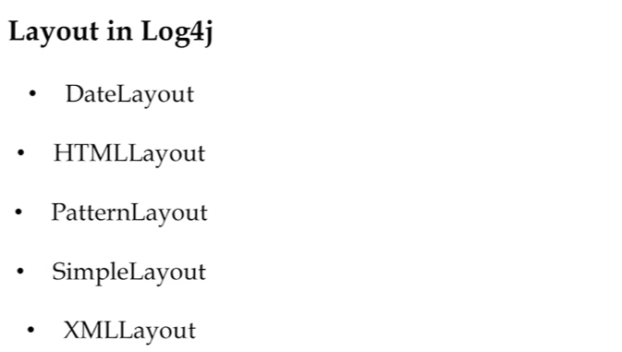
2. We will discuss in next lecture.